KWIC algorithm based on Object-Oriented Architectural

Architecture
As requested, in the laboratorian assignment, we will have to deal with these modules:
- LineStorage module, responsible for holding all characters from all words and lines.
- Read_file module, responsible for reading the data from a file and storing it in LineStorage module.
- CircularShifter module, responsible for producing circular shifts of lines stored in LineStorage module.
- Alphabetizer module, responsible for sorting circular shifts alphabetically.
- Output module, responsible for storing to new file the sorted shifts.
- Run_KWIC module, responsible for controlling the sequence of method invocations in other modules.
Following the OOP ideology, we will have to deal with data not shared among modules, but used via methods in the provided classes. Setters and getters and also objects come in help for this purpose. Below is a design of the architecture:

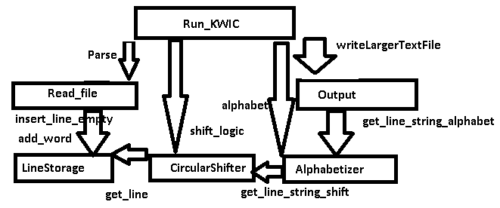

Figure 1: Architecture of KWIC system

A design pattern that is common in OOP. It is used in the thinking process as when the source code is not available, it hides complexities. And it has a single wrapper class that contains other members. (Arrows are public methods)

Class UML Diagram
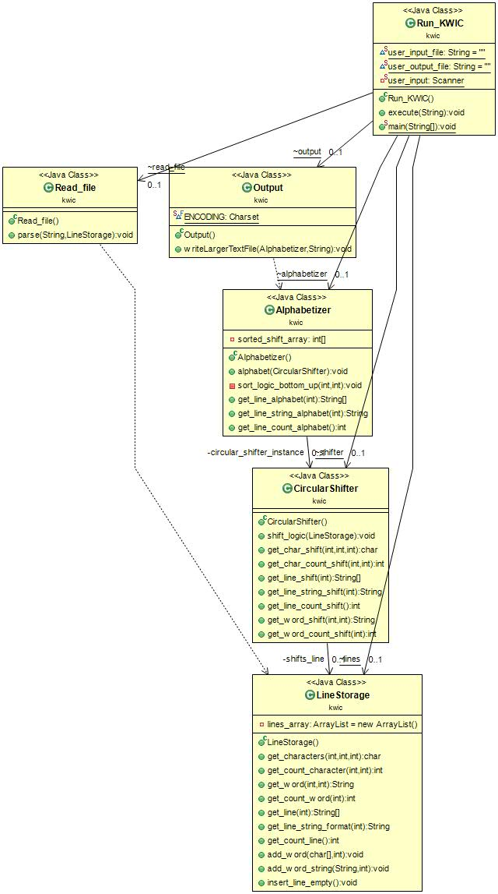

Figure 2: Class diagram of KWIC system
After analyzing the architecture design, we made the class via UML. It is better for us as it tells information about:
- How the mapping from proposed architecture to classes was done.
- Classes are easily readable as the show what is public, private, protected. So, we have a clear idea what the connection between classes might be (what uses what from what class).
- Association is the translation of the relationship.
The concepts of OOP, encapsulation, in UML are clearly visible. Signs such as +;-; public, private illustrate it. Like, in attributes of a class (instance variables), - says that cannot be manipulated directly. So an instance variable of that class has to have an object of the associated class. This explains the association between classes.
Class Description
Alphabetizer | Sorts all lines after it gets them from the shifter.
CircularShifter | Makes the shifts for the lines.
Read_file | Parse the file.
Run_KWIC | Calls the objects in the appropriate way
LineStorage | Manipulates the lines
Output | Saves in new file as according to specifications
Alphabetizer
It has two variables, sorted_shift_array and circular_shifter_instance. In the array we memorize the sorted index of lines and with the instance we take the lines. These will be needed in the methods: alphabet, sort_logic_bottom_up, get_line_alphabet, get_line_string_alphabet, get_line_count_alphabet.
In the alphabet method, we pass instance of the circular shifter in order to sort. The get methods, as their name suggests, do that operation that they are named after. And in the sort_logic_bottom_up we deal with the heap.

CircularShifter
When we pass the lines, it is this class that does the circular shifts. It is nearly the same logic as LineStorage for changing the lines. In addition, here we have lines that are circular shifts of the passed lines. And in difference from the LineStorage, here we only have get methods for getting the lines, words, characters at a position and also count them.

Read_file
As the description suggested, this should only read file. As tale, the only method it has is parse (from the naming parse the file). In the method, among other inputs, we can notice the instance of LineStorage, as like this we can store the lines.
Run_KWIC
Here we find all the other classes instances, as here they will be called. The calling of them is made according the specifications.
LineStorage
As the name suggests, it holds lines and public methods to work upon them. As per description we have the relation line-words-characters, the methods in this class, allow to other classes to:
- Insert a new/empty line
- Insert/get/delete a line as per index
- Count of lines
- Count of words per certain line
- Empty word to certain line
- Add word to a certain line
- Manipulate a word in a certain line
- Get count of characters in a certain word in a certain line
- Insert characters to a certain word in a certain line
- Manipulate character to a certain word in a certain line

Output
Save to a new specified file from user all that work.

Sequence Diagram

Viewing UML we can see how objects interact, and in order to enrich the understanding, we have to see in each step what happens.
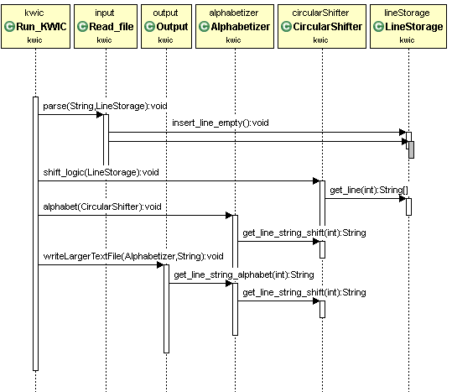
Figure 3: Sequence diagram of KWIC system

How everything works?
The main class that makes references to others, so every method should be executed according to the algorithm and OOP logic is the class Run_KWIC. As tale, the parse method of the Input class instance is run. As per method requirement, it takes the filename, and instance of LineStorage.
It reads the file, where for each line in file, a line in the LineStorage is made, an empty one. Afterwards, the method that inserts is called.
The shifting steps are than invoked via its instance. Here the lines, represented as LineStorage lines, are iterated and shifting is performed.
Sorting in alphabet order is the next step, via instance the Alphabetizer is called. Here, the above Shifter is processed, all the shifts, via the corresponding method.
Finally the output is saved to a new file. Where the above result is taken. The method iterates in all lines (now in alphabet order), and the index is the one that is sent to the shifter (sorted index is sent).
Heap Sort
As we will do some sorting, here we use the heap sort as an in-place algorithm. As this, it has the property of using data structure, and the input, as the algorithm is executing, it is substituted by the output. Here not numbers are compared, but strings of the line.

